080419Android Sticky Scheduler
Use Case Diagram

Submitted to:

Prof. Ma. Rowena C. Solamo
Faculty Member
Department of Computer Science
College of Engineering
University of the Philippines, Diliman

Submitted by:
Buera, Louie
Cabiles, Miguel
Palaganas, Genesis Ian

In partial fulfillment of Academic Requirements
for the course
CS 191 Software Engineering I
of the
1st Semester, AY 2014-2015
Revision Control

History Revision:
Revision Date | Person Responsible | Version  Number | Modification
09/10/14 | Miguel Cabiles | 1.0 | Initial Document; Version number should match the one below.
09/24/14 | Miguel Cabiles | 1.1 | Revised Use-Case Model, updated descriptions.

System Name: 080419Android Sticky Scheduler

Description: As the project name suggests it is a scheduler for the android platform. It aims to assists students specially in the collegiate level to manage their time. It's core features are as follows: Scheduler, Calendar integration and Location Based Functionalities.

Use-Case Diagram:

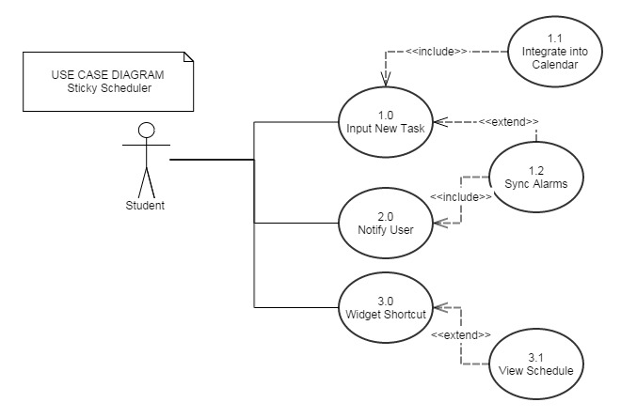

List of Actors:
Actors | Description
Student | This actor represents the user of the software. The student inputs information about the schedule, with the option of adding notes and enabling location-based alerts.

List of Use-cases:
Use-Case | Description
Use-Case 1.0 Input New Task | The user inputs information about a new task. Information includes task name, time and date when the task is due. Notes are optional.
Use-Case 1.1 Integrate into Calendar | The task should be added to the user's phone calendar automatically by the application.
Use-Case 1.2 Sync Alarms | The user is given the choice to input when he wants to be reminded of the task via phone notifications. This includes the time, date and possibly the place when the task should be done.
Use-Case 2.0 Notify User | The app should inform the user when an alarm synced in 1.2 is due.
Use-Case 3.0 Widget Shortcut | The user may have a shortcut to the app via phone widget. The widget would also have a list of upcoming tasks through a sticky notes interface for quick access.
Use-Case 3.1 View Schedule | The user may view the list of tasks through an interface either within the app itself or through 3.0.

